**PROJECT**

**4th Increment Report**

**on**

**“APP RECOMMENDER”**

**By**

**Sumanth Koushik Kalli**

**Alekhya Boyapati**

**Vinil Kumar Kamigari**

**Importing Existing Services/API:**

The existing services used in this increment are:

* HTML language, JavaScript, Cascading style sheets (CSS) and PHP for designing web pages according to the mobile platform.
* MySQL Database for storing User’s personal information, sending email notifications to users according to his/her interests and retrieving results from output files in HDFS.
* Apache Hadoop for processing of Application’s data.
* Java for sorting the applications from a comma separated text files and writing into output files.
* The source code for all the services are uploaded in the Github account and the link is given below:

**Detail Design of Services:**

In this design of mobile interface we created a Login interface for taking input about user’s interests and also allowing the user to select different categories of apps, which he/she wants to see. Whenever a user clicks on particular category, all the apps related to that category will be displayed in descending order according to their average rating given by users.

Users can sign up in this application and store the categories they are interested in so that we can send them app recommendations based on their interests.

**Sequence Diagram:**

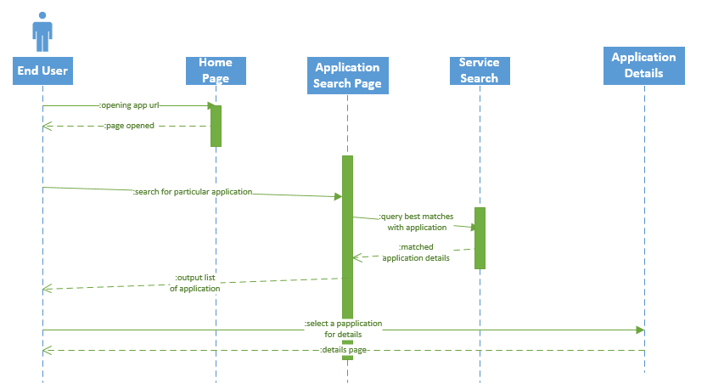

**System Architecture Diagram:**

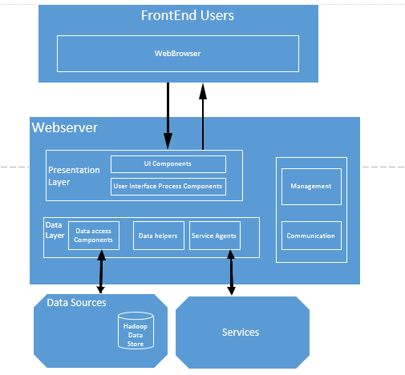

**Implementation**

**Implementation of services:**

We created login page and sign up page for existing and new users to enter the application. However we are going to use Hadoop for analyzing app data and displaying them in decreasing order of their app rating. This is achieved by using a Java program deployed as a jar file in Hadoop. The java program compares the average app rating and the number of recommenders to sort the apps.

**Generate your datasets:**

App data is collected from the Google Play store and then arranged into the .txt files. We have taken different categories that are available in Google Play store and a dataset is created for each category. So, whenever the user clicks an app belonging to a particular category, then all the text files pertaining to the available 27 categories are analyzed using Hadoop and the result is stored in a MySQL database to retrieve the records faster and display to the user.

**Implementation of user interface (Mobile Apps):**

The user interface is designed using the HTML language, Cascading style sheets, PHP and MySQL Database. This user interface allows the user to setup an account for him and share his/her interest with the application to get the best apps in his/her interested category.

**Report:**

In our project “APP RECOMMENDER” we provide the user with genuine reviews about apps in a particular category. In his first visit to the app, user has to create an account with username, password and email. Later he can login using the details given above. After setting up his profile, he/she can choose category/categories of his/her interest to view the tops apps in that particular category. The best apps will be displayed in according to their rating and recommendations provided by other users. Then the user can go into specific app details like rating, number of recommenders, 5star, 4 star, 3 star, 2 star, 1 star ratings and genuine reviews.

The user can also manage his/her interests by clicking “Manage interests”, where he/she can select multiple categories and this will be saved for further reference. The user will be receiving recommendations to email weekly for those particular categories which he/she had selected.

In case the user forgets the password the password reset link will be sent to his email by clicking the “forgot password” tab and then entering his username. The user also has the opportunity to change the password by selecting the “change password” tab. Here he has to enter his old password first then the new one.

The screen shots of the above functionality are displayed below in mobile environment

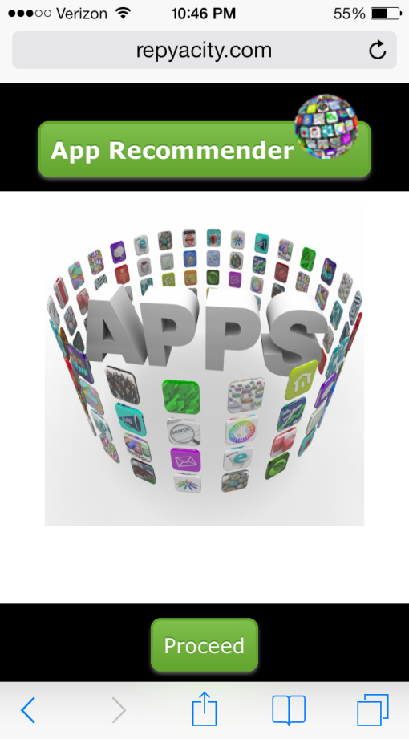 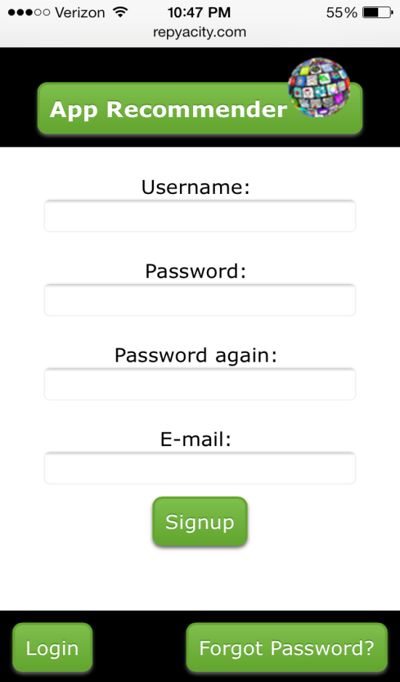

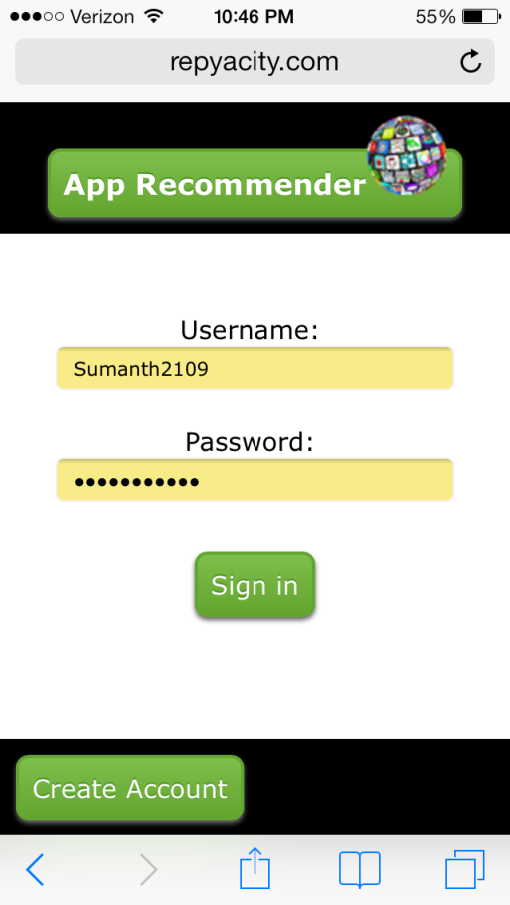 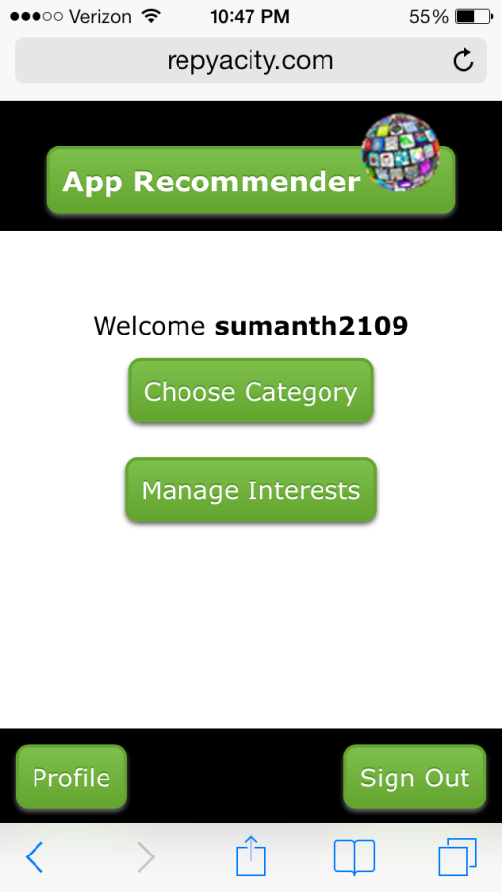

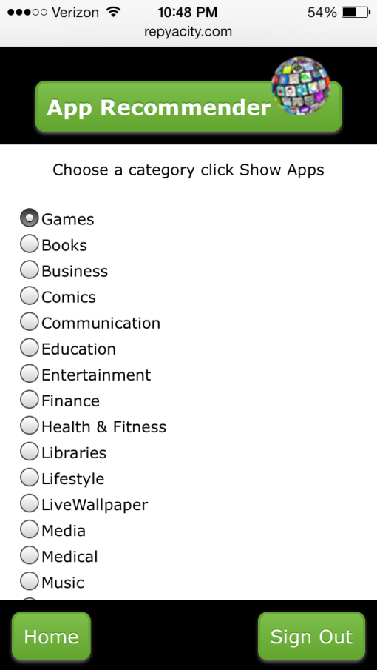 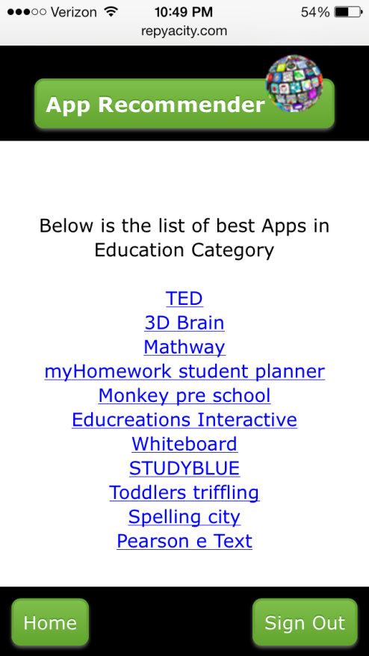

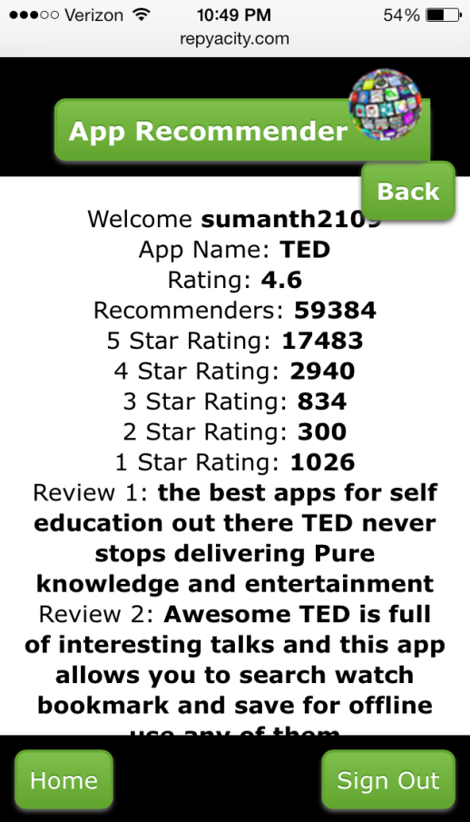 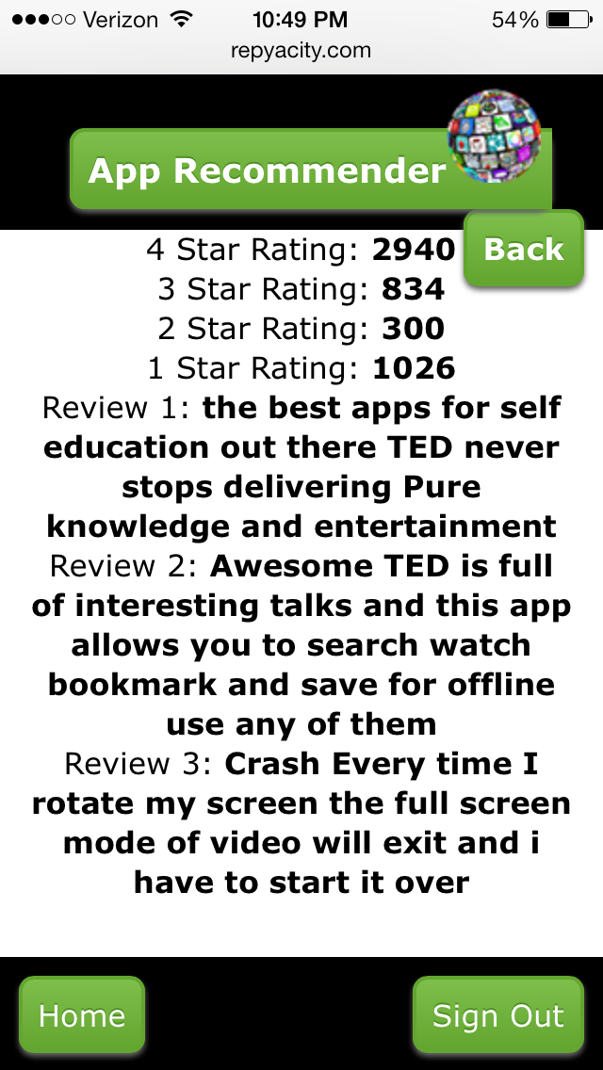

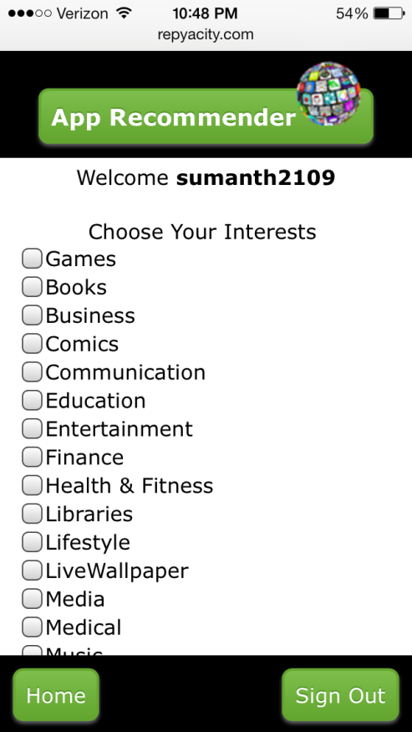 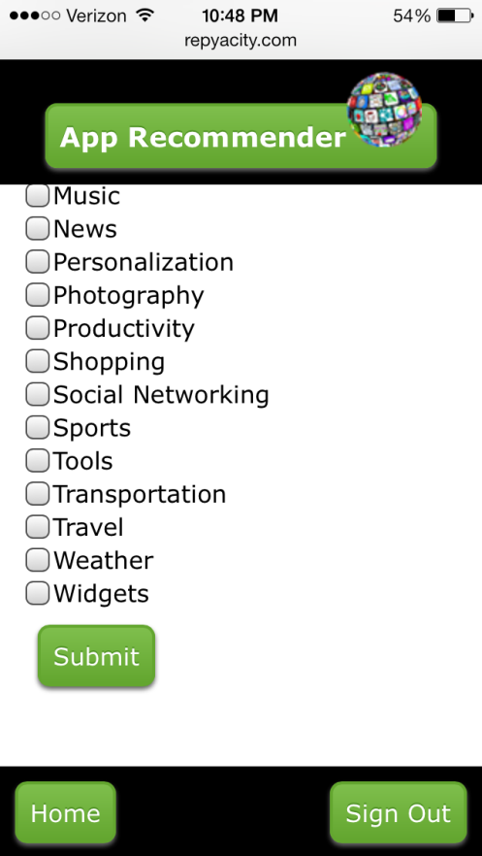

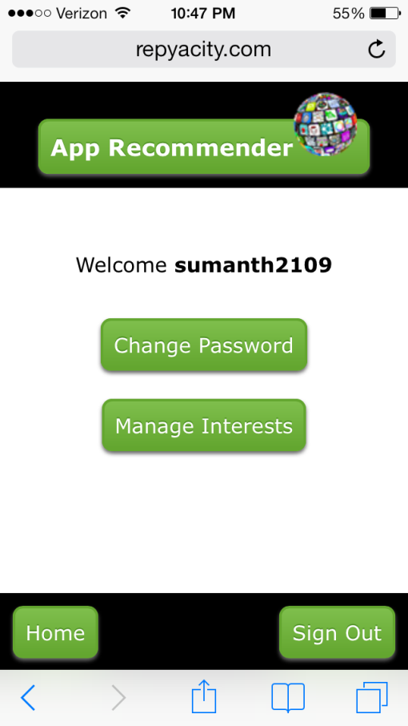 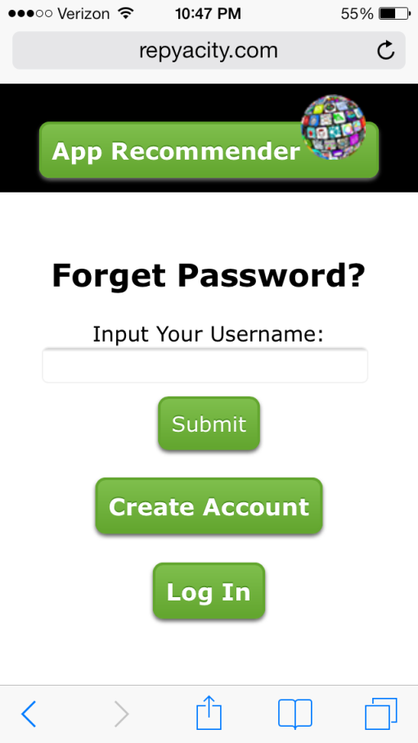

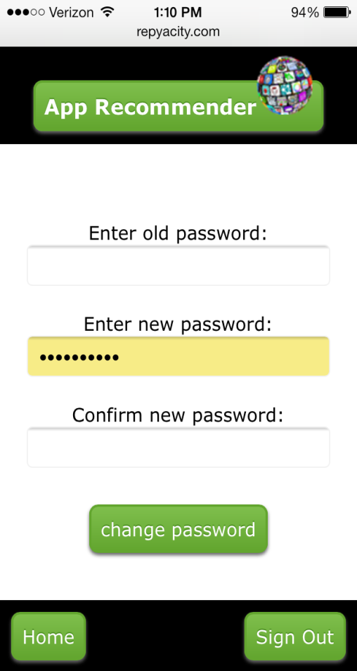

**Project Management:**

The project has been regularly update in ScrumDo and the link of the ScrumDo is given below:

<https://www.scrumdo.com/projects/project/mcc-final-project/iteration/78656/board>

**Implementation Status Report**

**Work Completed:**

* **Description:** In the final increment, we had collected data about App’s [App Name, Average Rating of the app, Number of users recommending this application, Number of users rated 5, Number of users rated 4, Number of users rated 3, Number of users rated 2, Number of users rated 1, Reviews for the app]. Data about applications in various categories are collected into the text files and is analyzed using Apache Hadoop using the IBM Big Insights.

We have created an application recommendation system which sends out recommendations to the users by email based on their interest. For this functionality we created a signup account for users, where in they can submit their personal information and create and account in our application so that can change their interests in future. A Java program is written to rate and display the apps based on the average rating given by other users and also the number of recommended for this application.

* **Responsibility:**

**Data Collection:** Data about apps are collected from the Play store byAlekhya and Sumanth. The data collected includes App Name, Average Rating of the app, updated date, size, installs, current version, required android, developer name, Number of users rated 5, Number of users rated 4, Number of users rated 3, Number of users rated 2, Number of users rated 1, Reviews for the app.

**Documentation:** Documentation for the 4th increment has been prepared by Sumanth Koushik and Alekhya Boyapati.

* **Time Taken:** We spent 140 hours each for getting data, modifying the Java Program to get the results in required format and for creating the User interface using HTML, CSS, JavaScript and PHP. MySQL database is used for storing the user details.
* **Contributions:**

**Alekhya:** Data Collection, Inserting the functionalities in user interface, video presentation and part of fourth increment report.

**Sumanth:** Data collection, Modifying Java program and collecting output files, designing the user interface and connecting it to MySQL database, Video presentation and part of fourth increment report.

**Vinil:** Java program execution and creating jar files.

**Future work and Issues/Concerns:**

The future work of this project is that if we can find an API for the apps where in app data can be update automatically, then Hadoop can be used to its maximum to analyze the huge amount the data contained in Google play store or Apple’s app store.

Another future work which can be developed on top of this project is Hive can be used to store the results from the HDFS and bringing the results to the user interface.

The concerns we faced in this increment are:

* To run the project in the local host we installed Apache server and during PHP installation, we could not load “php5.dll” file into the server. We faced a problem in installing it; we solved this problem by uploading the project to online domain.